**EXPERIMENT NO: 4**

**Aim: Perform and Evaluate Classification Algorithms using any open source tool.**

**Open Weka Explorer:**

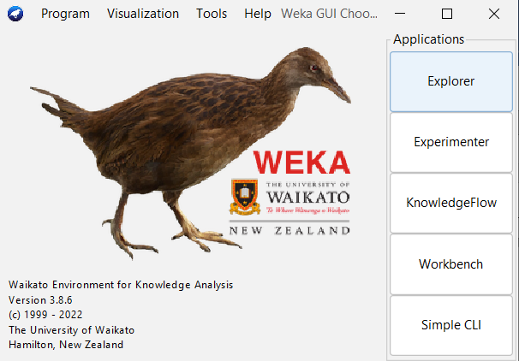

**Load the titanic dataset:**

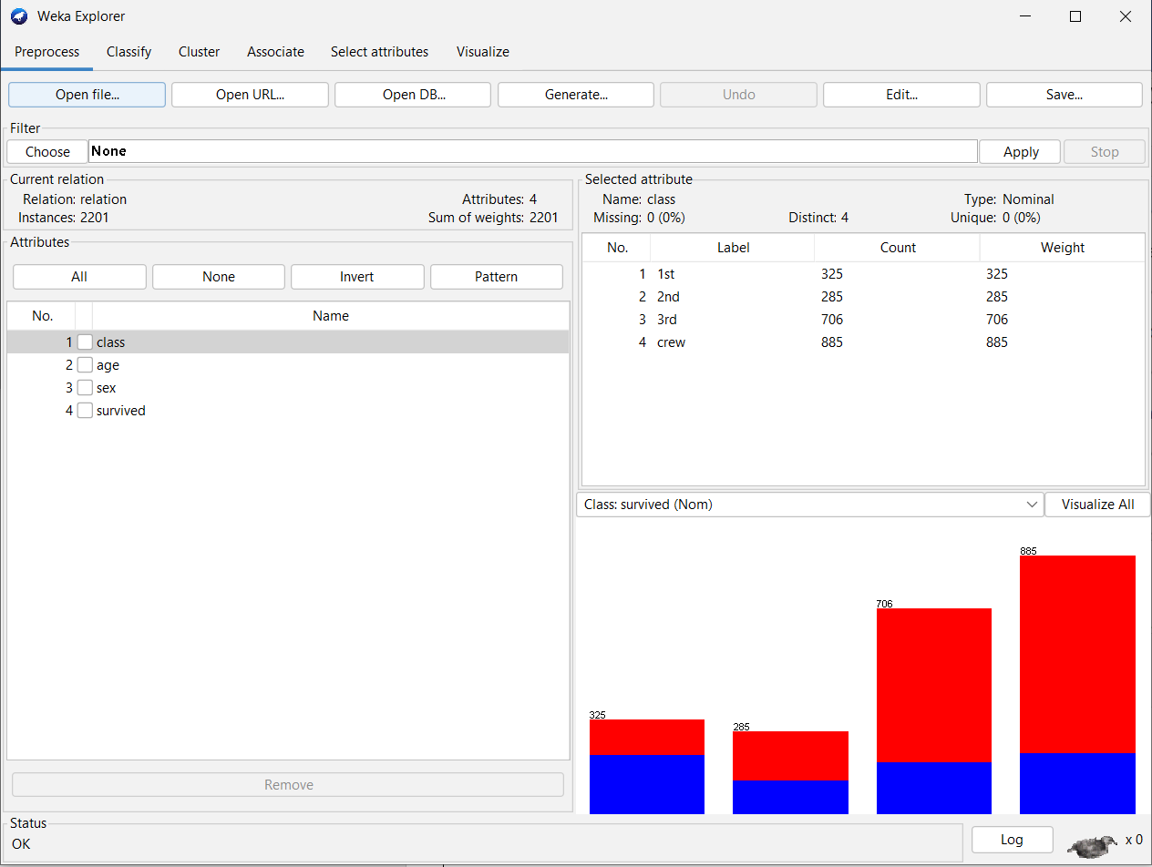

**Visualize all the attributes:**

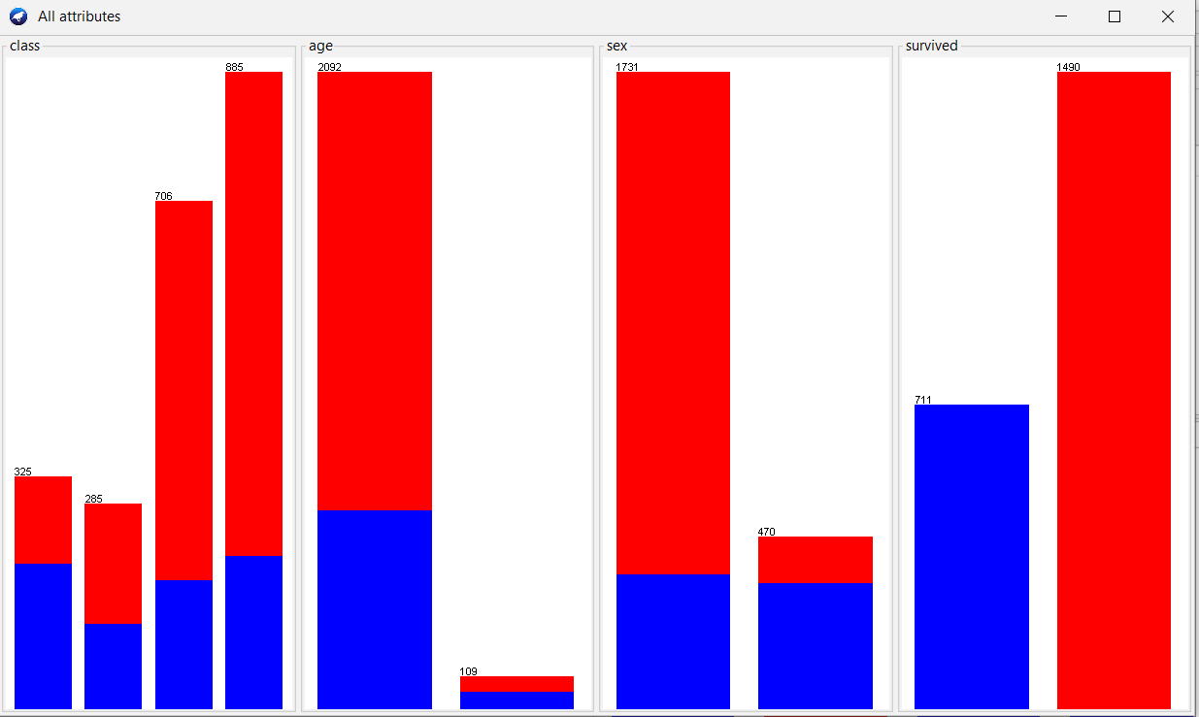

**Apply the Naïve Bayes Classifier:**

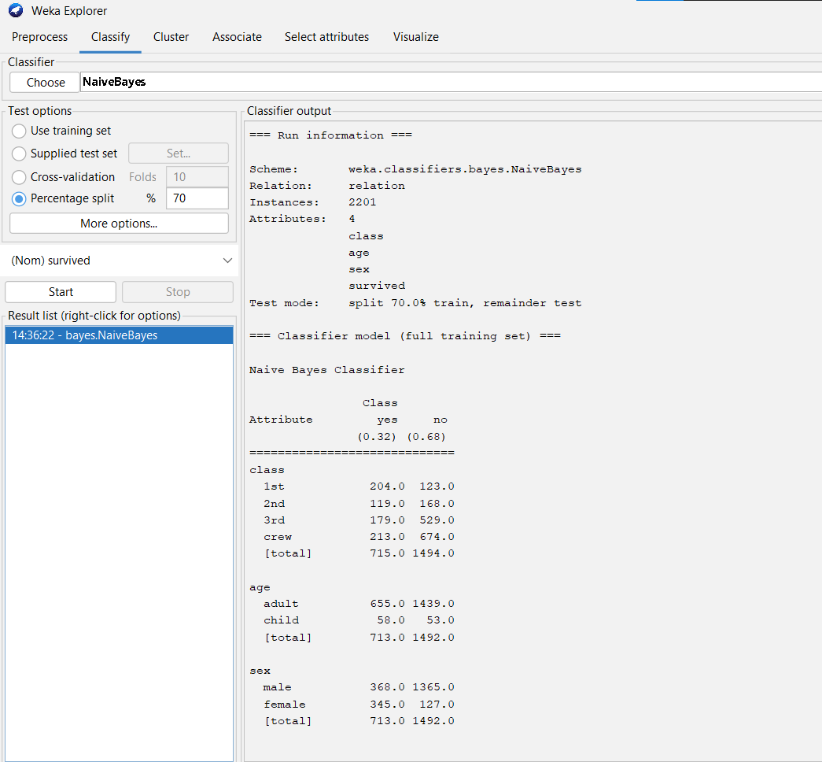

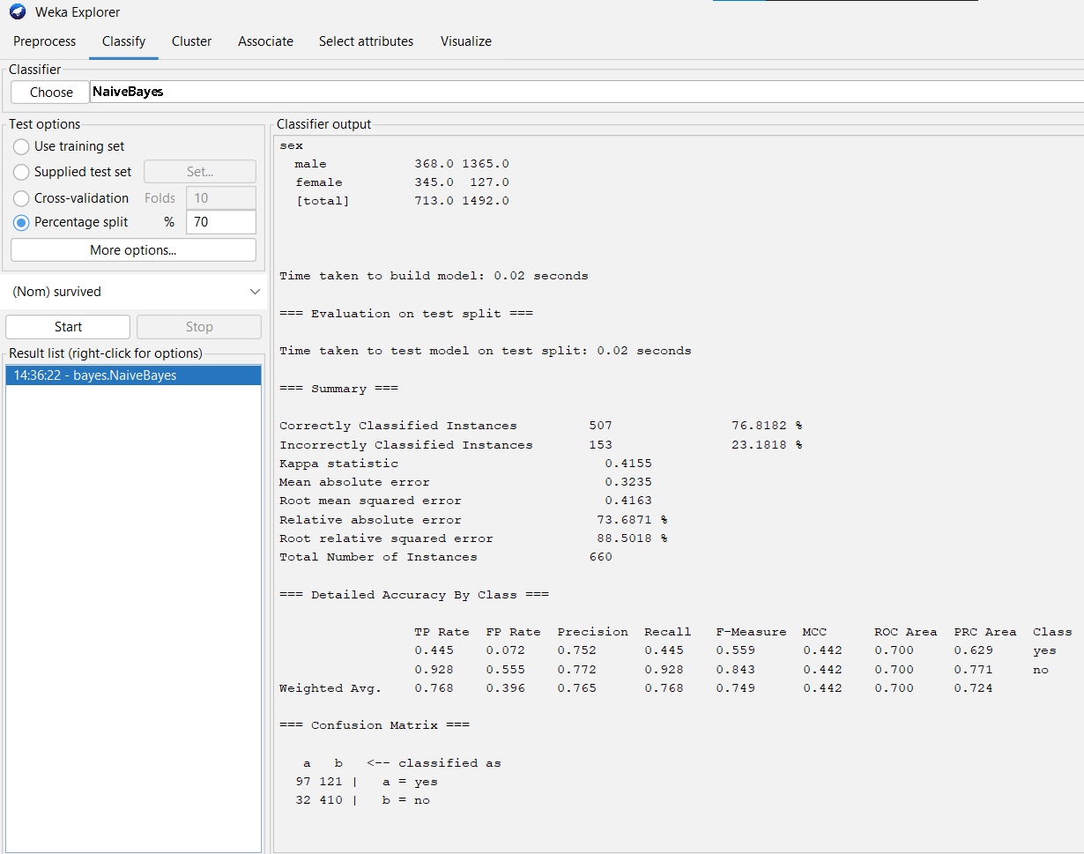

**Apply J48 Classifier:**

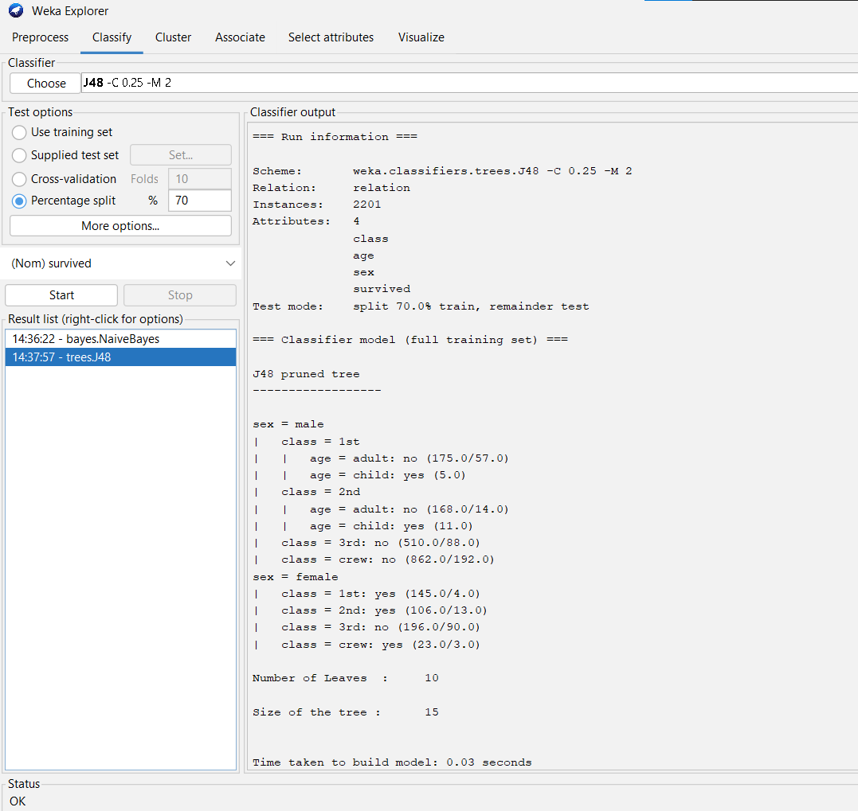

**Visualize Tree:**

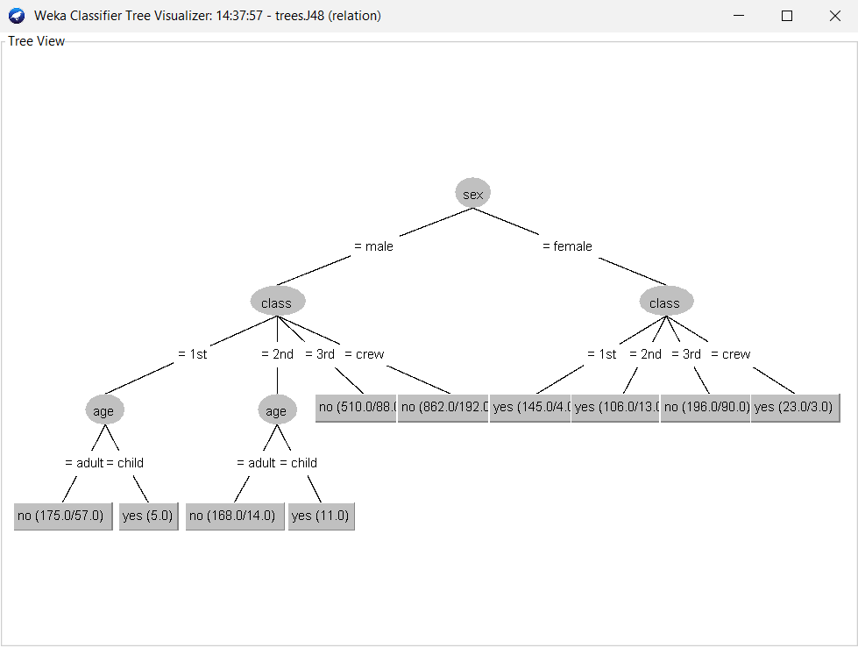

**Conclusion:**

Hence, we have successfully studied to implement and Evaluate Classification Algorithms languages like JAVA/ python/R